University of Engineering & Management, Kolkata
NAAC SSR
Criterion 7.1.3: Alternate Energy Initiatives

Use of Renewable Energy
The University has installed solar power plant on 19th June, 2019, having a capacity 10.24 kWp on the roof top of the 1st building (B1) of the University and there is no connection with 2nd (B2) and 3rd (B3) building. It met the power requirement of the 1st building of UEM Kolkata.
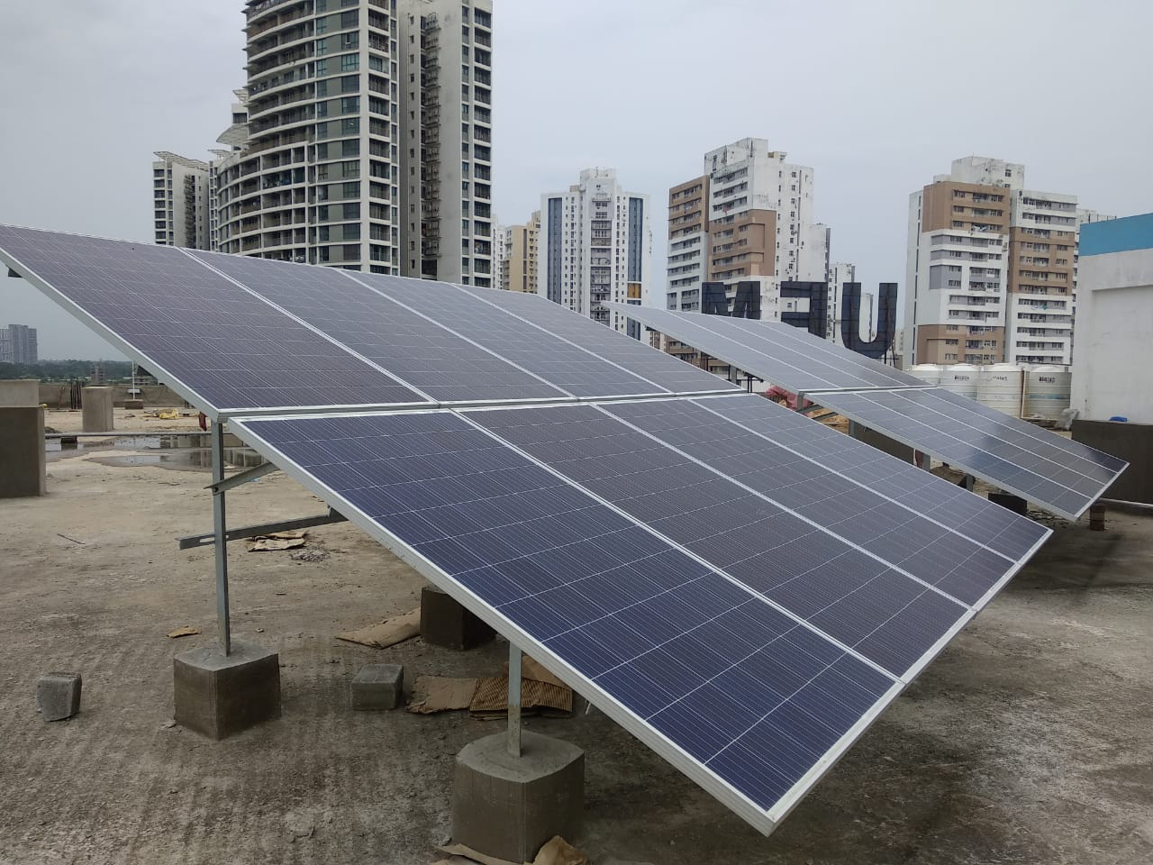

Annual power requirement of the Institution met by the renewable energy sources:
Data for 2020-21
Power requirement met by renewable energy sources | Total power requirement | Renewable energy source | Renewable energy generated and used | Energy Supplied to the grid
288 kWp | 288 kWp | 122.88 kWp | Varies 48 to 96 kWp | 122.88 kWp
Amount of Renewable Energy generated and used varies from 48 to 96 kWp because total renewable power sources are PV generated power, so it’s completely depends on the weather and seasons.
The Energy data month wise for the year 2020-2021 is tabulated below:
Month wise Renewable Energy Consumption (kWp)
Month (2020-2021) | Renewable Energy
July | 3558.25
August | 10721.57
September | 12339.59
October | 7172.22
November | 0
December | 0
January | 0
February | 0
March | 0
April | 0
May | 0

Graphical Representation of month wise Renewable Energy Consumption for the year 2020-21

Percentage of the annual power requirement met by the renewable energy for the 1st building of the University= 8.33%
Energy Consumption Scenario:
University is committed to deliver continuous and sustainable electricity in the campus so that all the academic and official activities are carried out smoothly. The total sanctioned load of University of Engineering & Management, Kolkata is 350 kVA. Based upon their consumption there are five categories which share some percentage of total load is depicted below.

Total Power Consumption data set month wise for the Year 2020-2021
Month (2020-2021) | Power Consumption (kWh)
July | 13069.75
Aug | 11910.50
Sep | 13856.50
Oct | 17804.25
Nov | 17134.50
Dec | 11690.75
Jan | 12737.25
Feb | 14192.75
Mar | 200065.25
Apr | 16782.25
May | 8791.50

Graphical Representation of month wise Total Power Consumption for the year 2020-21

The University is also going to install IoT based 3 phase Industrial Meter to track consumption of energy/ electricity for any phase high capacity equipment. It can be operated through Wi-Fi and mobile internet. This equipment track energy consumption using smart industrial power sensor and e-bots App.
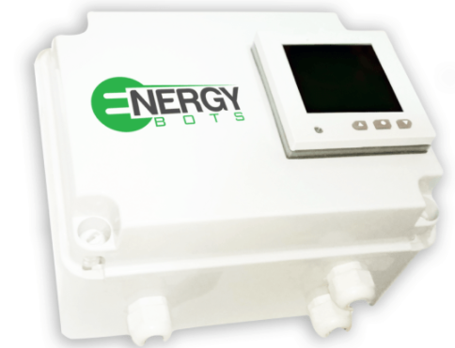
IoT based 3 Phase Industrial Meter

