University of Engineering & Management, Kolkata
NAAC SSR
Criterion 7.1.7: Green Practices
Green Practices
The University of Engineering & Management, Kolkata is committed to make Clean and Green campus. Faculties of this University always encourage students to implement eco-friendly projects and campaigns for the sustainable development in the environment. The total campus is surrounded by a number of various trees which enhance natural beauty of the campus as well as reduce temperature during summer.
- Use of Renewable Energy:

The University has installed solar power plant on 19th June, 2019, having a capacity 10.24 kWp on the roof top of the 1st building (B1) of the University and there is no connection with 2nd (B2) and 3rd (B3) building. It met the power requirement of the 1st building of UEM Kolkata. It reduce the carbon footprint and protect the environment from global warming.

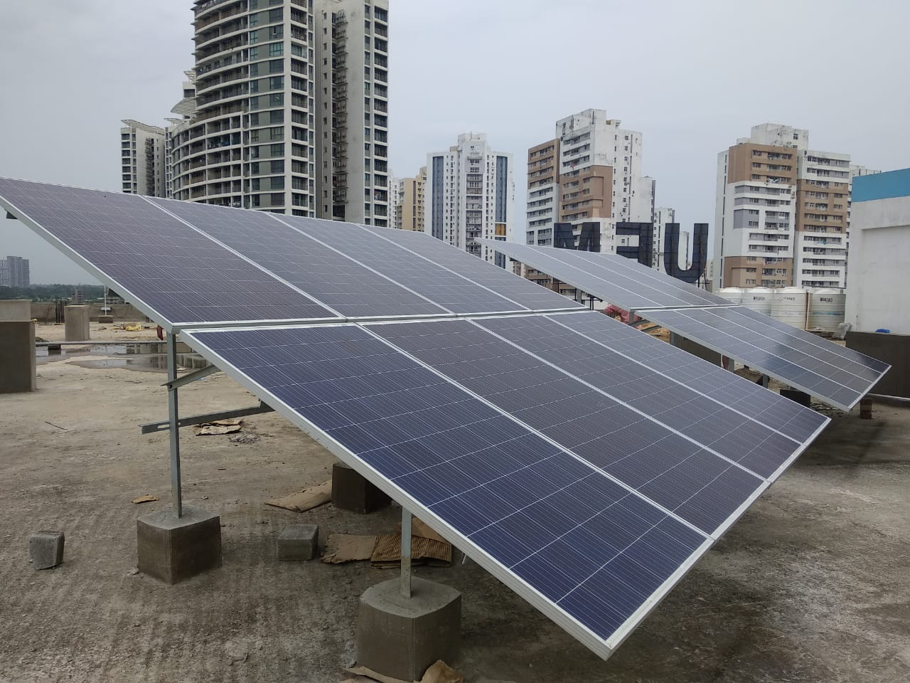

- Natural Vegetation:
There are number of bamboo trees are planted both sides of the campus. The benefits of bamboo trees are:
- It produce 35% more oxygen that an equivalent stand of trees.
- It sequester carbon dioxide and is carbon neutral.
- It is critical element in the balance of the oxygen and carbon dioxide in the atmosphere.
- Bamboo helps to keep the environment clean as it is a natural air purifier.

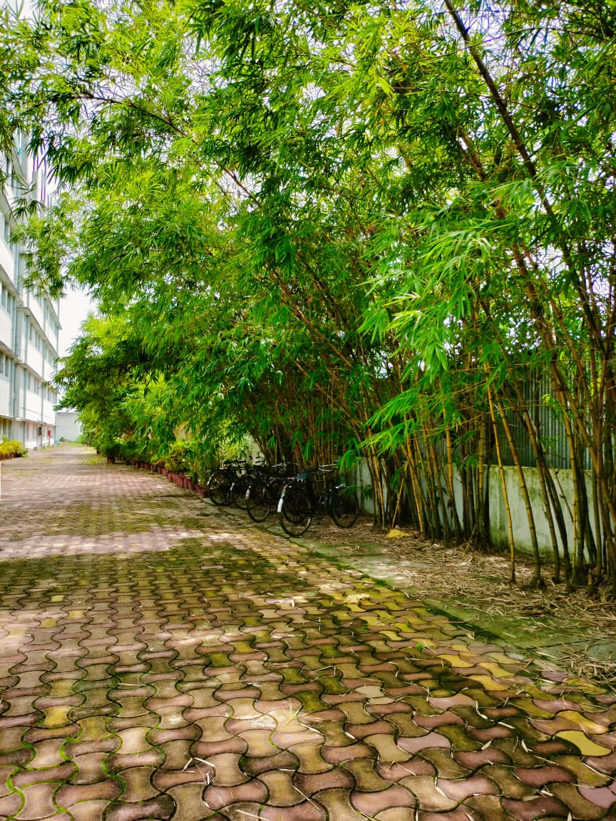

Bamboo Trees in the campus of UEM, Kolkata

Tree plantation is the most interesting event for the students and faculties of the University. University conducts plantation drive on regular basis in the campus. Tree plantation has been done along the boundaries of the campus. Some photos are depicted below where faculty and students are involved in tree plantation.

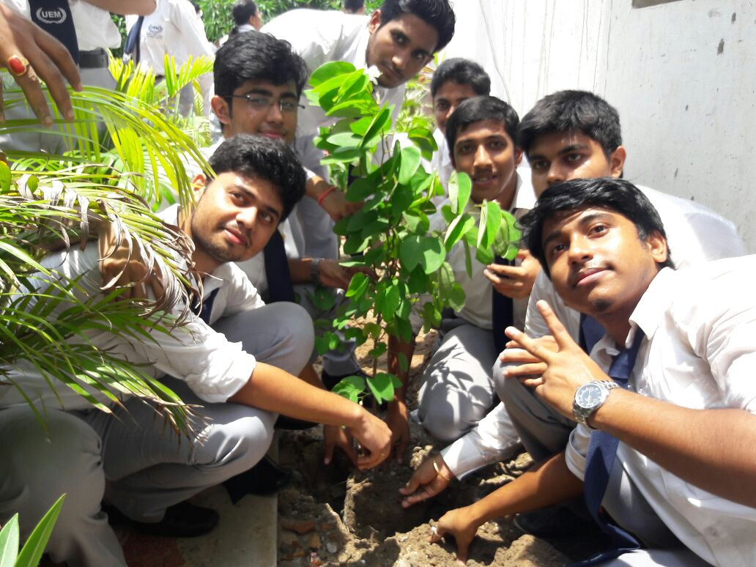
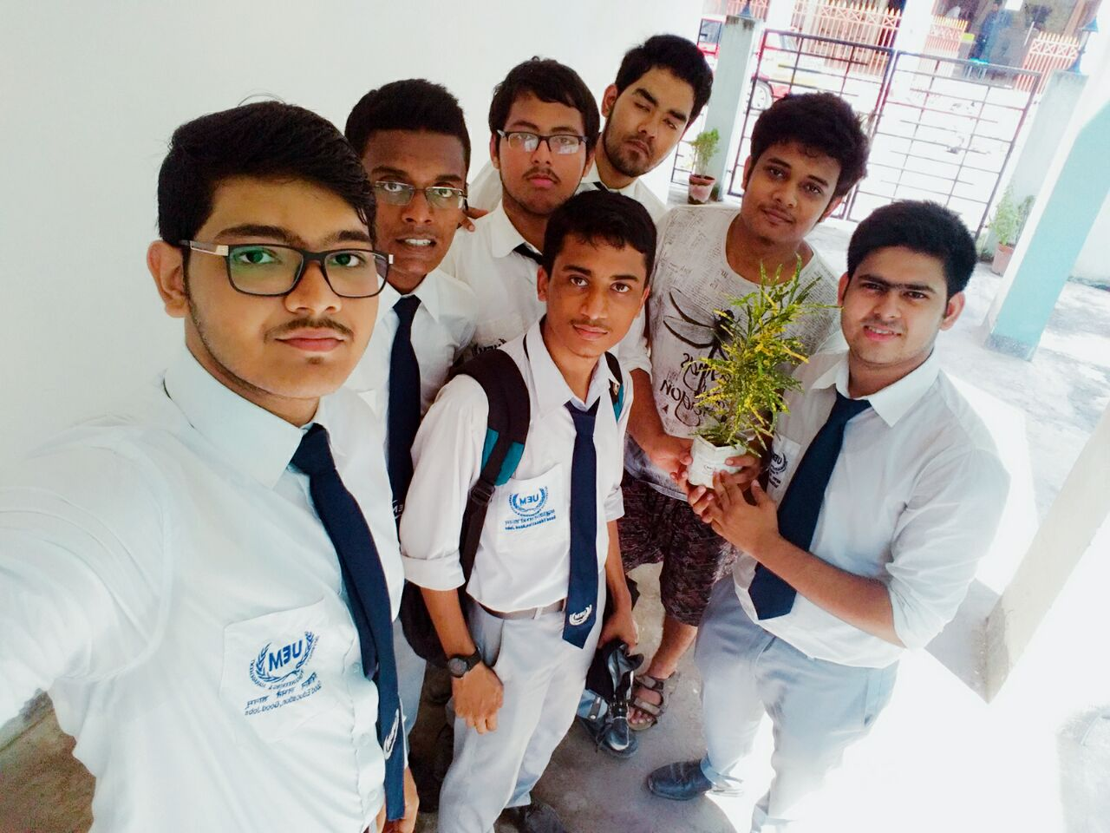

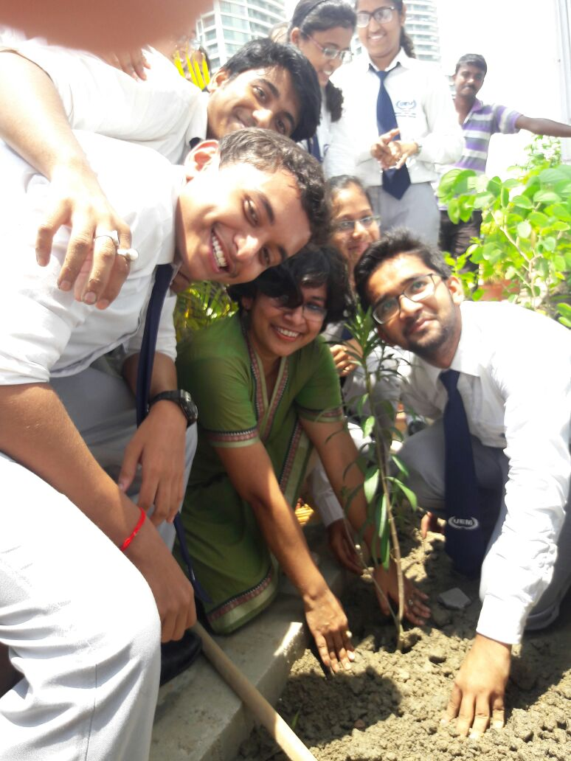
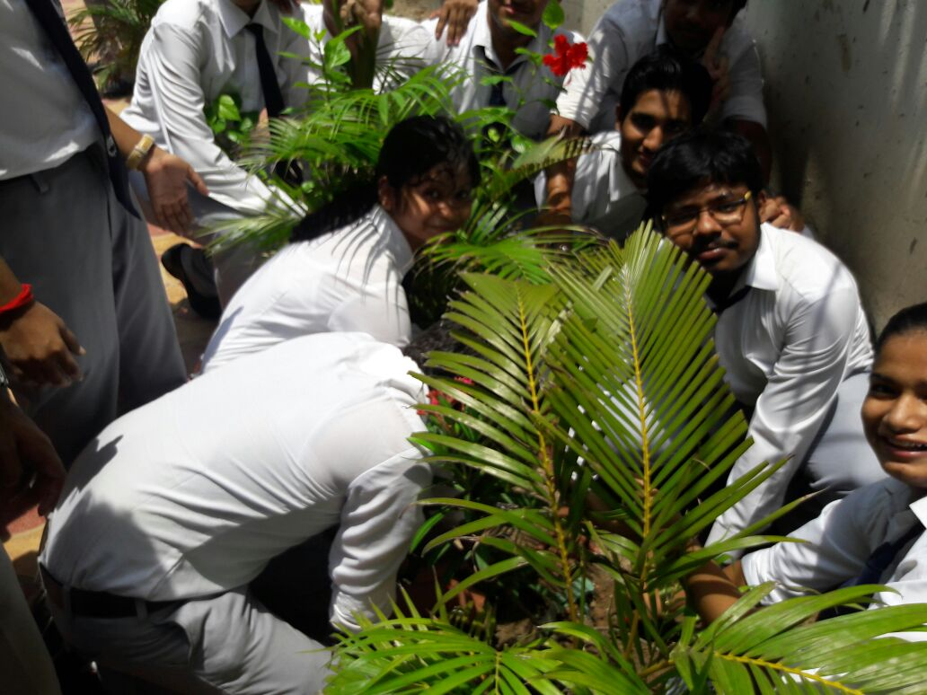

Some Memories of Tree Plantation

There are some trees of fruits like Mango, Jackfruit, Guava and Banana in the campus of UEM, Kolkata.
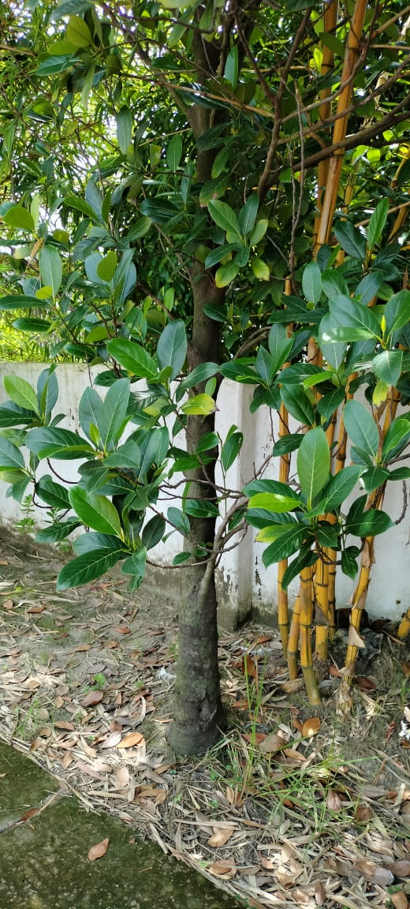
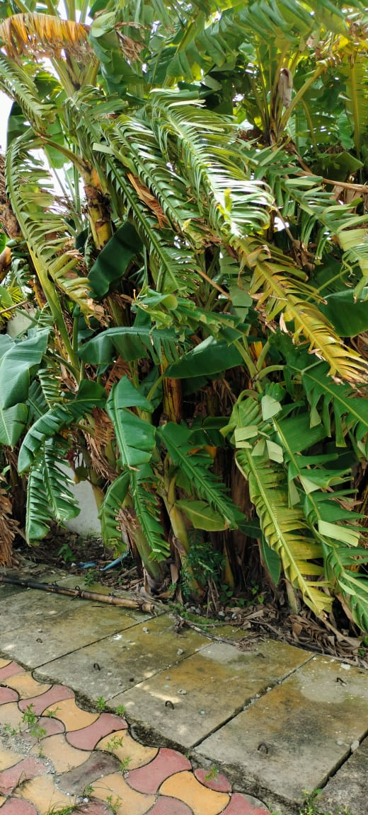

Guava Tree
Mango Tree
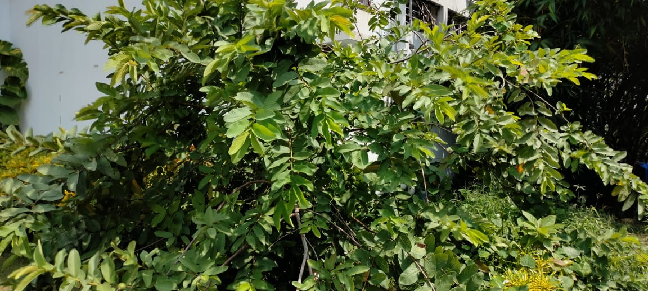
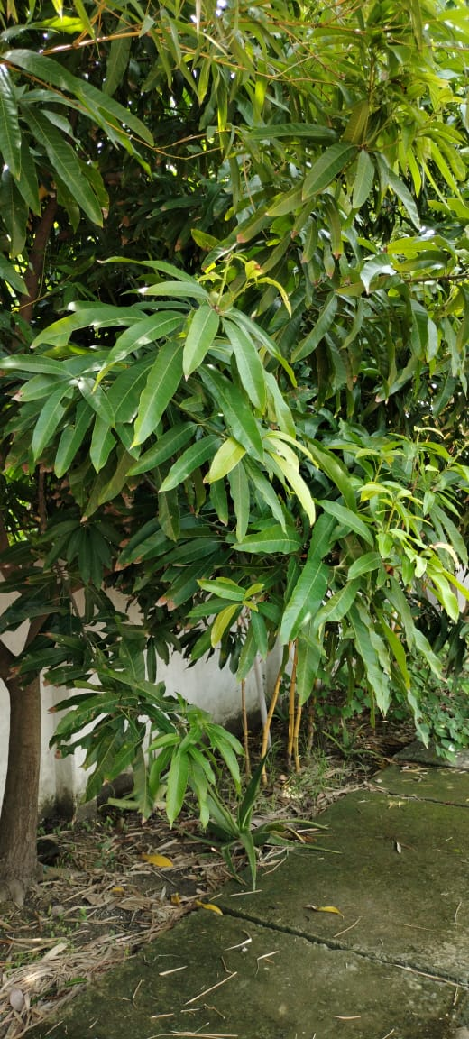
Banana Tree
Jackfruit Tree
Various types of flowers enhance the natural beauty of the campus of UEM, Kolkata.
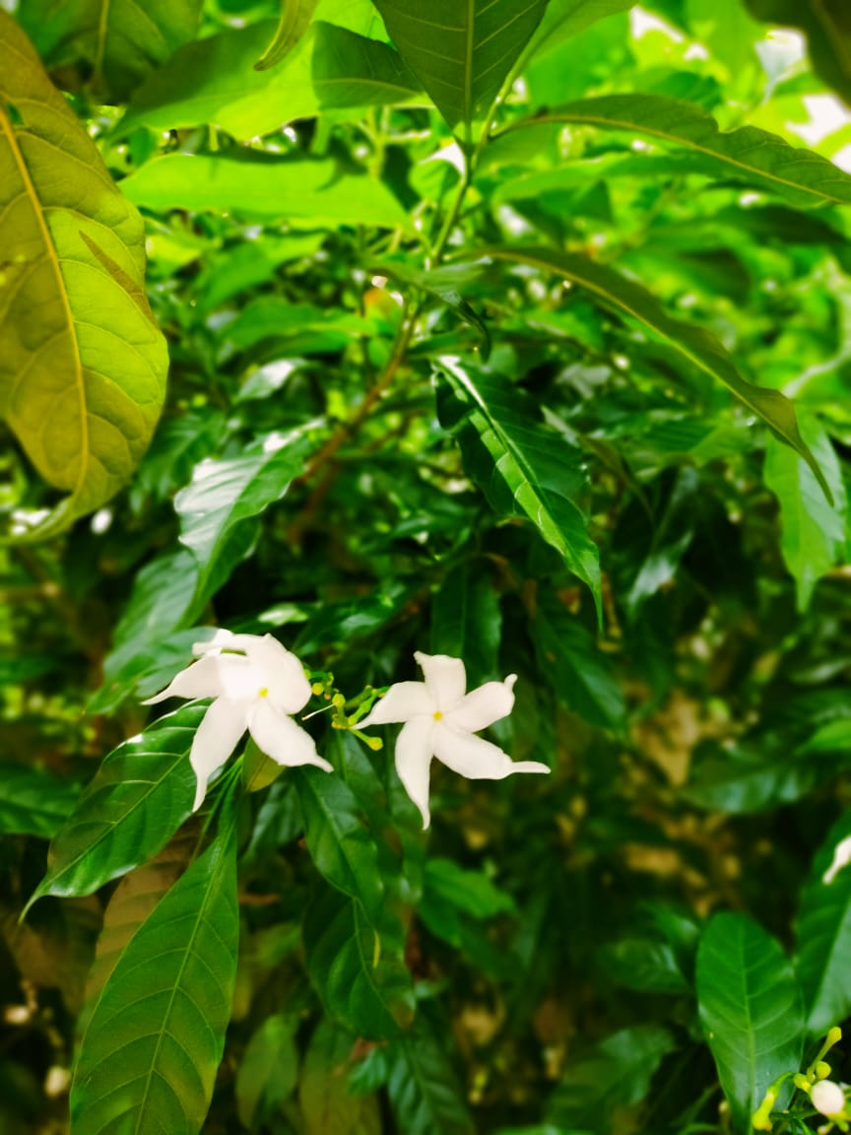 | 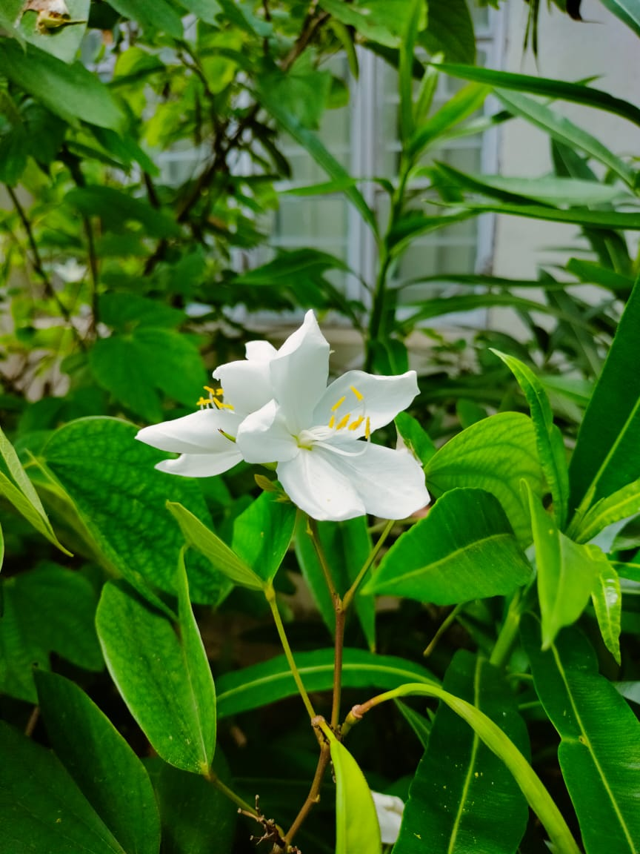 | 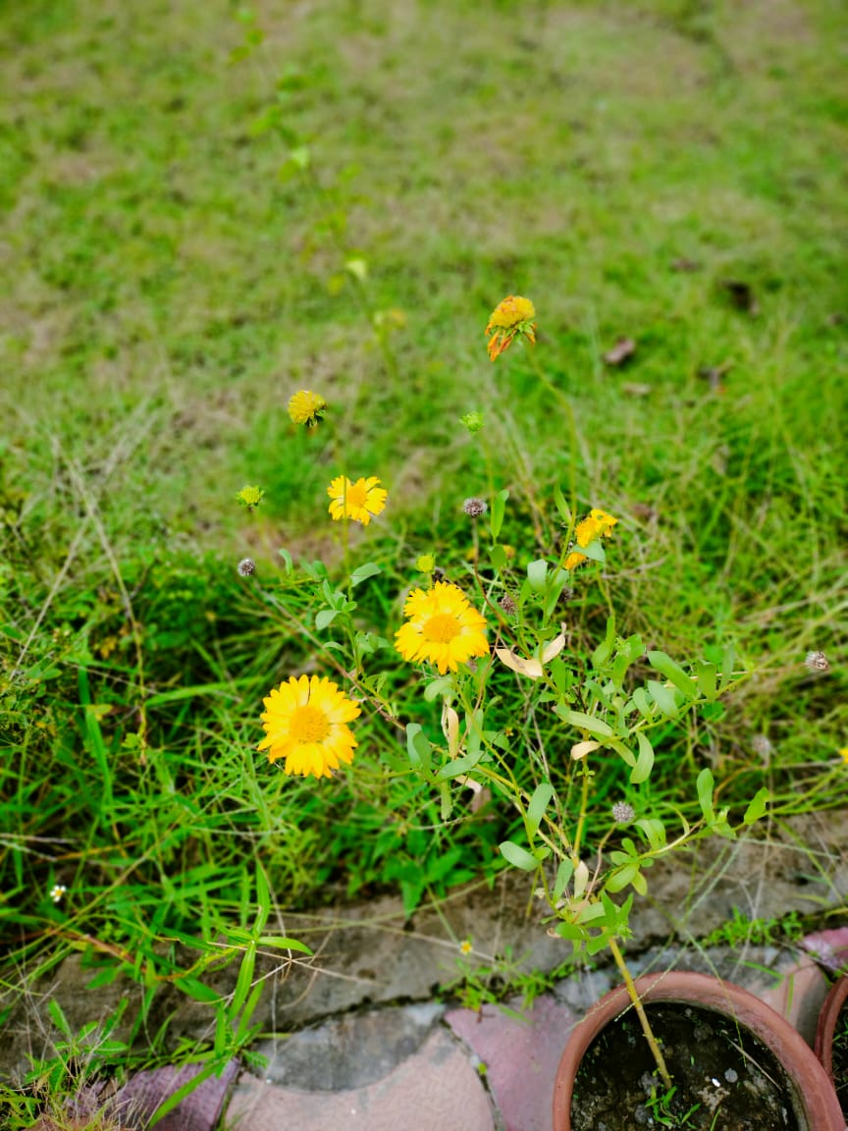 | 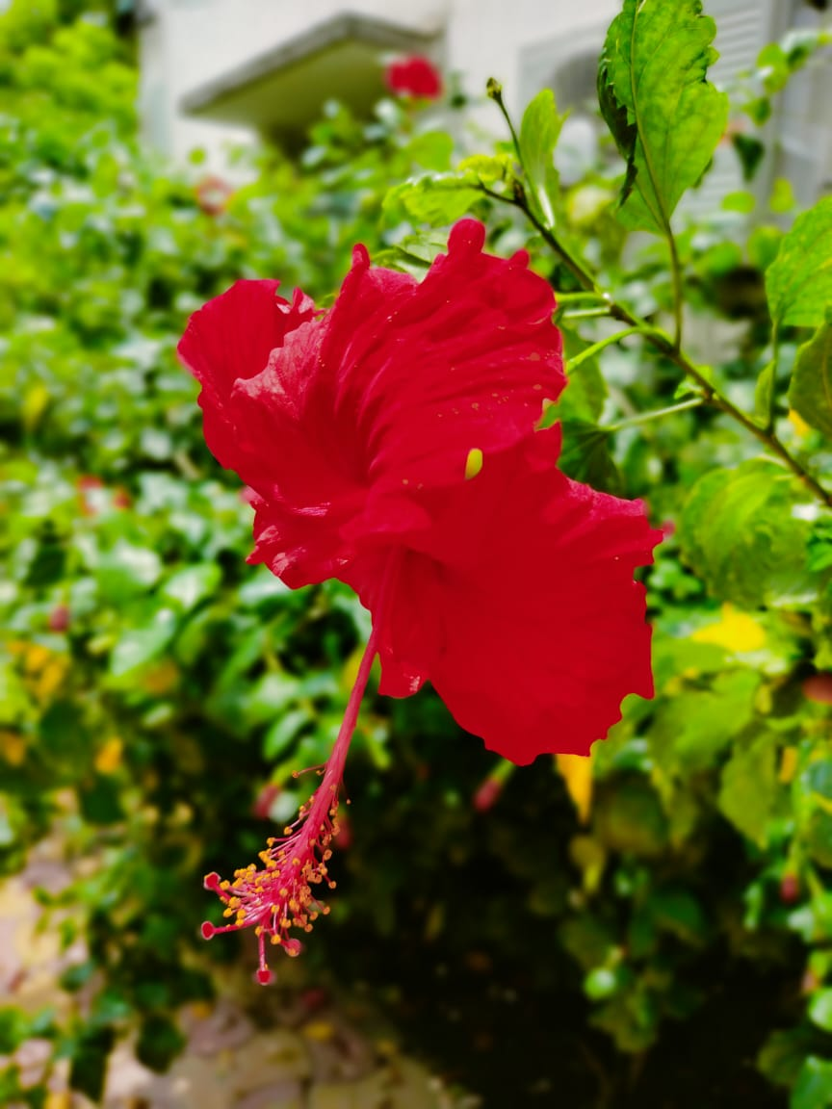
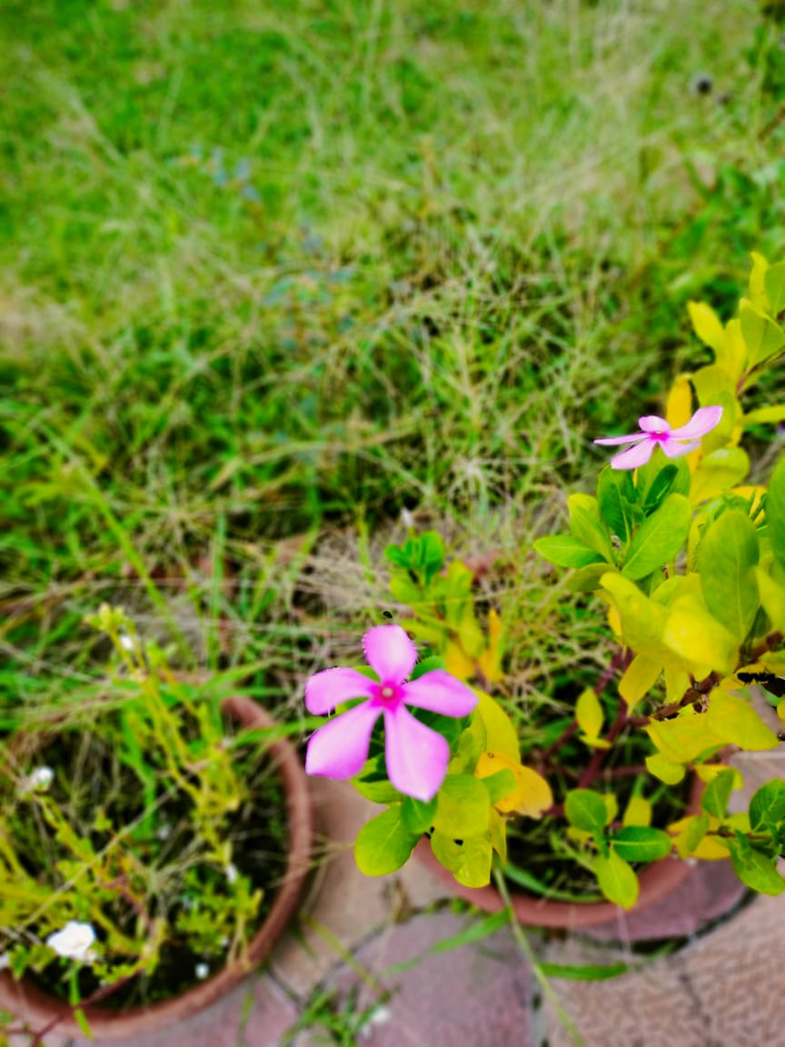 | 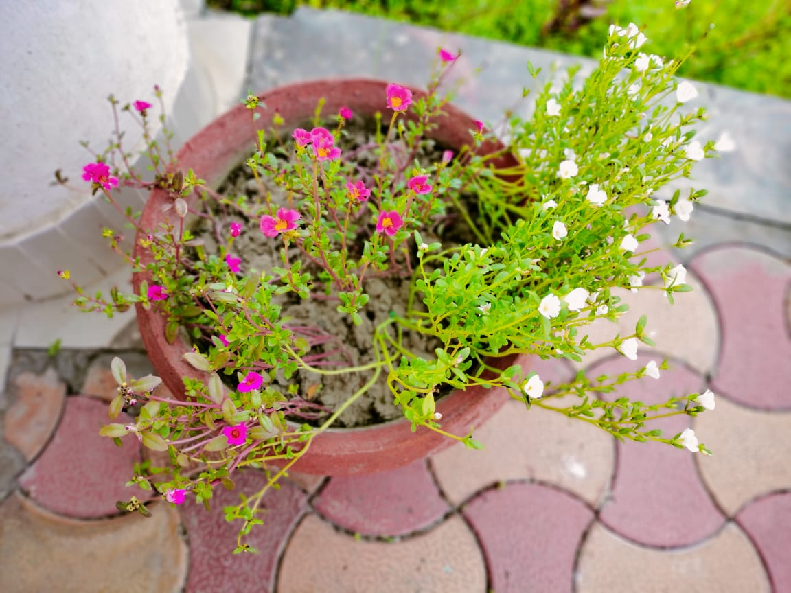 | 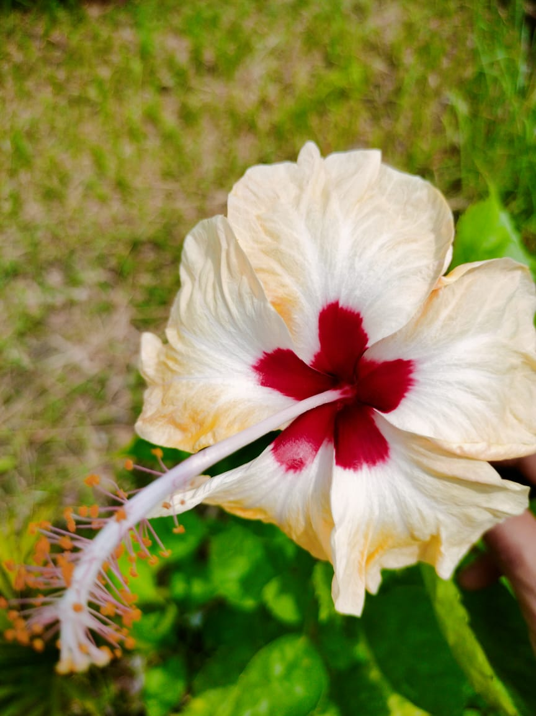 | 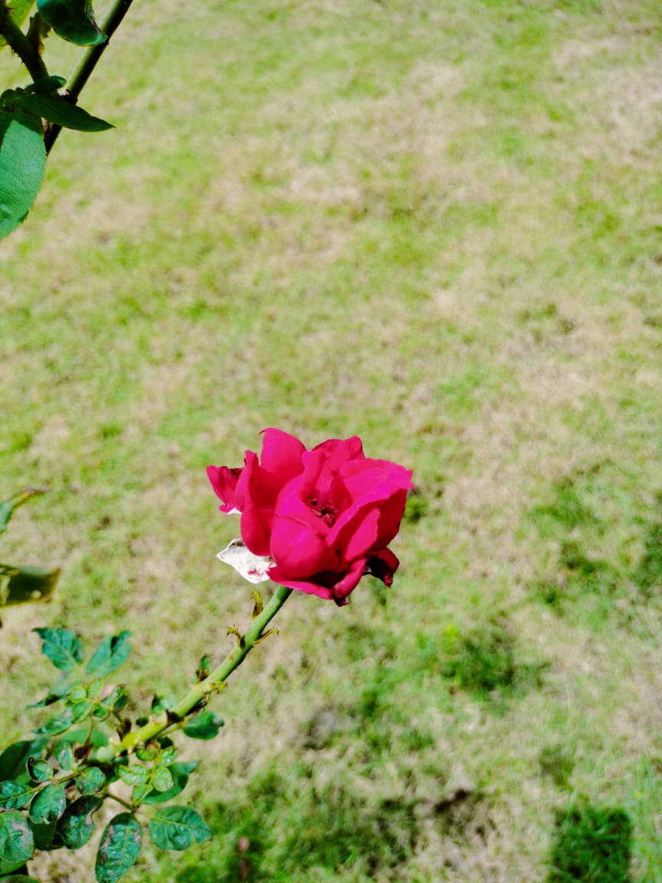
- Waste Management:
Various processes are followed to recycle the waste properly. The housekeeping staffs collect the waste every day and after that segregated. The non-biodegradable waste like plastic, glass, metal etc. are collected by the NKDA and bio-degradable waste are collected another box and after that decomposed using a decomposition powder. After some months it will used as a compost for gardening.
- Water Environment:
University has committed to make zero waste water environment in the campus. Various process are followed to reduce waste water.
- Automatic taps are installed in each and every washrooms and toilets. Since these are not operated manually so it reduce waste of water.
- A very small machine is installed inside the water tank so that when the tank become full it will automatically switched off which reduce waste of water efficiently. It is depicted below.

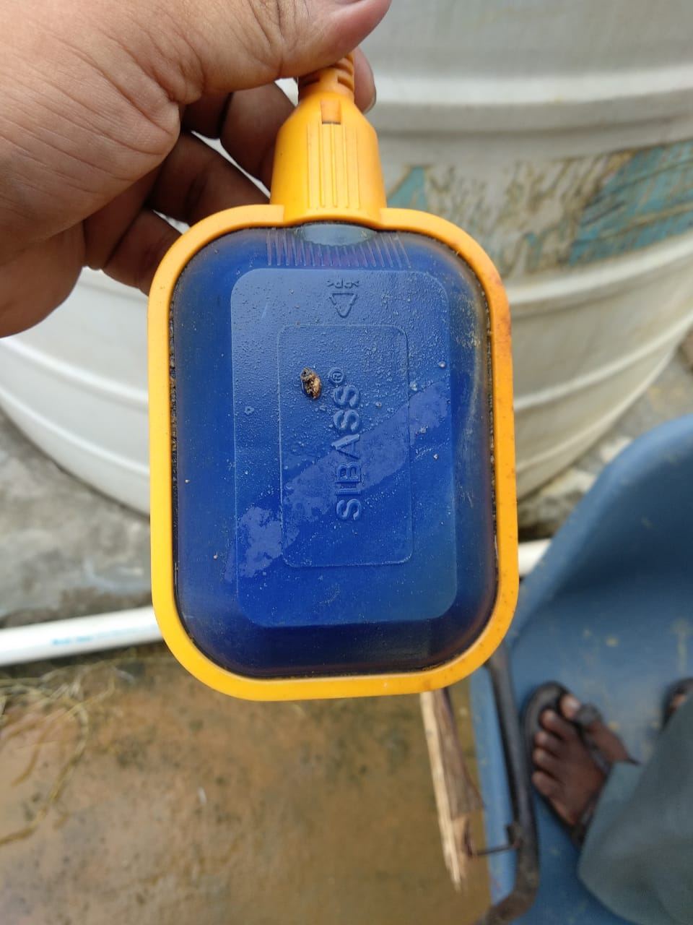
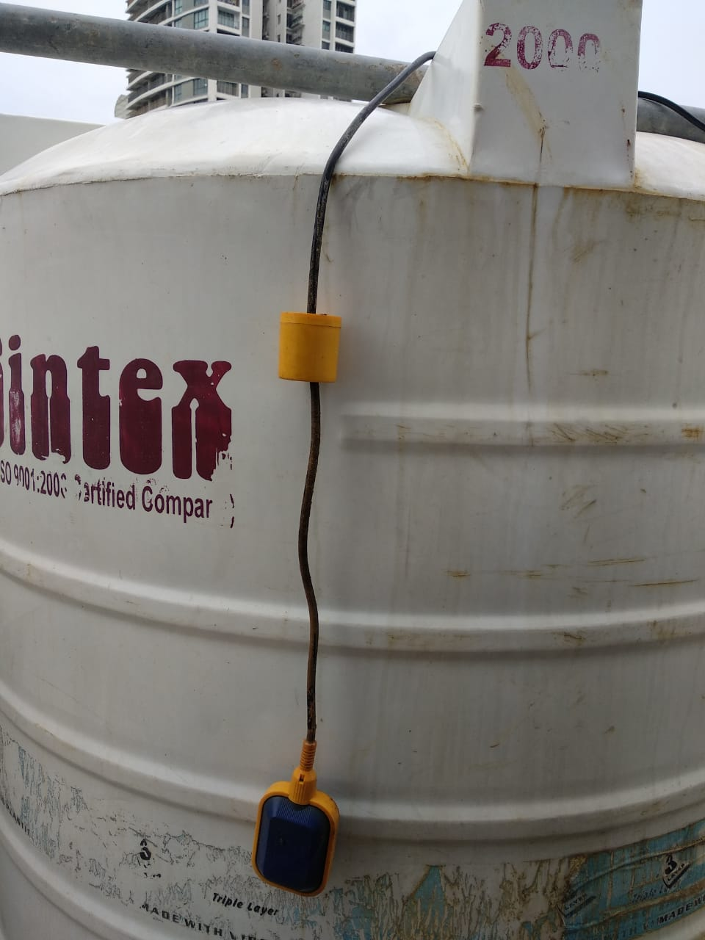

This University has also developed a plan for partly rain water harvesting. There is a well in the back side of University for rain water harvesting. The diameter of the well is 3 ft. and the length is 30 ft.
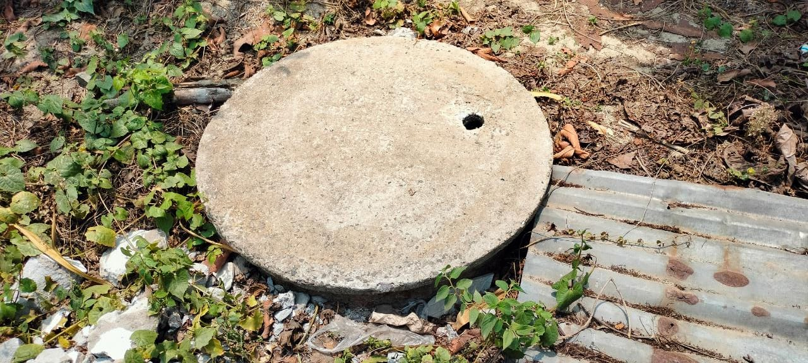
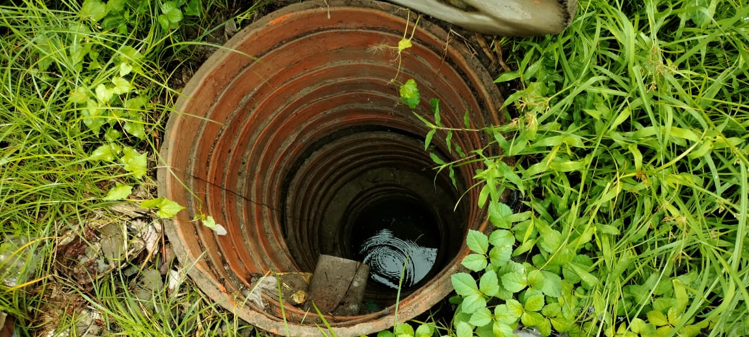

- Paperless Office:
University follow some mechanism to minimize use of paper for the academic and official purposes. Most of the working communication and data collection are carried out through e-communication like IEMCRP portal which is developed by the IEM (Institute of Engineering & Management) group. The HR activities, Leave application and Approval, Student Attendance everything are followed by the IEMCRP which reduce the use of paper. Staffs and faculties attendance are also monitored by the biometric.
- Public Transport:
University inspire faculty and staff to use public transport for daily communicating. University arrange some buses which are allotted for the student, faculty and staff for daily communication which ensure less carbon footprint in the campus. Most of the faculty and staff use college bus for daily communicating instead of private car to minimize carbon footprint.

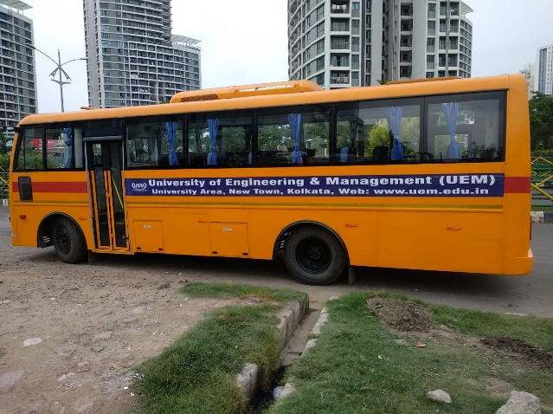
College Bus provided by the UEM, Kolkata
- Carbon Accounting for lowering the gases responsible for the Green House effect:
University ensure all vehicles entering the campus should have “Pollution Under Control” Certificate. Solar Energy system has an automated system which reduce carbon footprint. Campus strictly follow “No Smoking Zone” principle.

- Bicycles: Students and Staffs mostly use bicycle for daily communicating.
- Public Transport: Buses are arranged by the University for the Students, Staffs and Faculties for daily communicating.
- Pedestrian Friendly Road: The road connecting to the campus and within the campus are well maintained in terms of quality and cleanliness.

- Plastic free campus:

University encourage faculty, student and staff to use paper, biodegradable bags instead of plastic. In this concern canteen, stores are motivated to use paper for packing.

- Green landscaping with trees and plants:
Tree plantation drive is the most interesting activity in the University. University conducts plantation drive on regular basis in the campus. Tree plantation has been done along the boundaries of the campus. There are some trees of fruits like Mango, Jackfruit, Guava and Banana in the campus of UEM, Kolkata. Various types of flowers enhance the natural beauty of the campus of UEM, Kolkata. A trained gardener is appointed to maintain the trees properly.
- The Continuous Ambient Air Quality Monitoring System:
University is going to install continuous Air Quality Monitoring System. This monitoring system is able to measure PM 2.5, PM 10, CO₂, HCHO, TVOC, Temperature and Humidity. It support Wi-Fi and Mobile App enabled so that it can be monitored from anywhere any time in the campus.
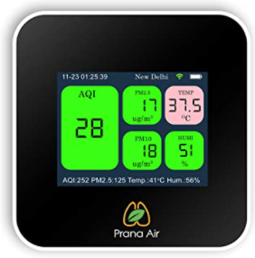

.

Air Quality Monitoring System

